Aim:

Design a push button switch interface- door bell control.

Apparatus:

Connecting Wires, Resistances, Arduino, LED.

Circuit Diagram:

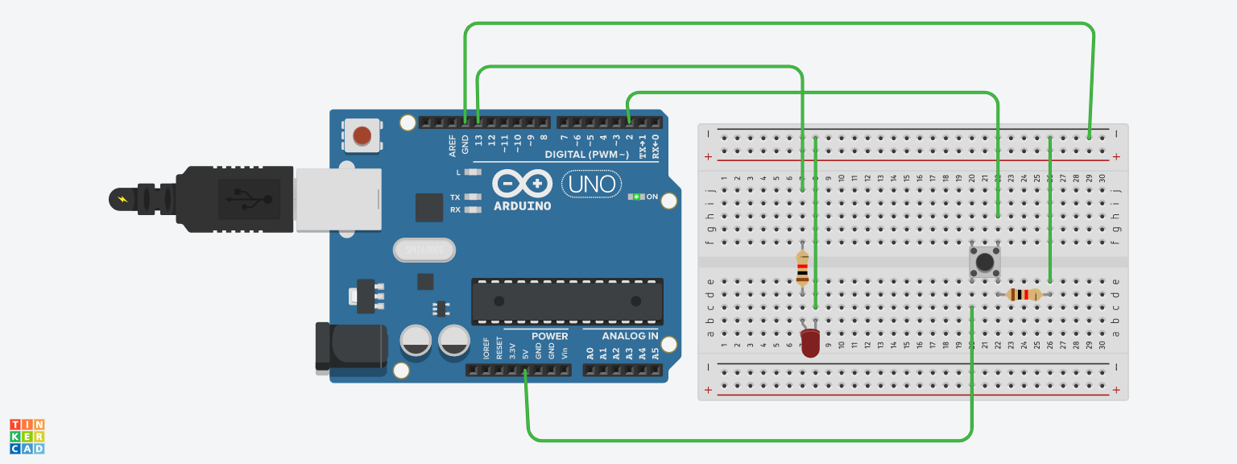

Theory :

LED is a light emmiting diode that gives light as a output. It is a semiconductor. They require very less power to get lighted and work very efficiently.

Arduino:
An Arduino UNO is a device that is equipped with digital and analog input/output slots. It has 14 Input/Output slots, 5 Analog slots and can work between 7 to 20 volts.It has 3 ground pins. It works when user inputs code into arduino.

Concept Used :

A push button switch is a small, sealed mechanism that completes an electric circuit when you press on it. When it's on, a small metal spring inside makes contact with two wires, allowing electricity to flow. When it's off, the spring retracts, contact is interrupted, and current won't flow.
Momentary switches work only as long as you press on them, like the buttons on a phone, calculator or door buzzer. They can be subdivided into normally-on and normally-off types.
Normally-Off
With the normally-off switch, there's no connection till you push the button. Most push button switches are used this way. Examples include doorbell buttons, cell phone keys and garage door openers.
Normally-On
Here the switch conducts normally, but interrupts the circuit when you press on it. This is more specialized, and may be used in conjunction with a wiring trick. For example, connecting a normally-on switch in parallel with a light bulb will light the bulb when the button's pushed; otherwise, current will flow through the switch, leaving the bulb off.

Observation :
When we pass electrical signals to the arduino through our code and press the push button, the buzzer buzzes and gets off accordingly.
Learning Outcomes:

- Learned about the different components in an Arduino.
- Learned how to connect the wires in an Arduino, and breadboard and writing the program.

Problems :

- Connections of LED may not be connected properly.
- LED's may not be working.
- Code may be wrong
- Arduino is not working.

Troubleshooting:

- All connections should be checked properly.
- Arduino should be working.
- LED's that are in working conditions should be used.
- Right code must be used.

Precaution:

- Don't plug in an LED without a current limiting resistor.
- Don't supply more than 9V unless proper knowledge.
- Check all the connections.

